**Project Title:** Robotic Hand Control Using Flex Sensor for Handling Hazardous Chemicals

**Abstract**

This project focuses on developing a robotic hand that responds to human finger movements. Instead of using an EMG sensor, the system utilizes flex sensors to detect finger bending and translate it into mechanical movements. The detected signals are processed by an Arduino to control servo motors. This system is designed for remote handling of hazardous chemicals in chemical plants, reducing human exposure to dangerous substances. It offers an affordable, easy-to-use, and customizable solution for industrial safety.

**Introduction**

Workers in chemical plants often face risks while handling hazardous materials. This project aims to develop a robotic hand that mimics human finger movements using flex sensors, allowing workers to control it remotely and safely handle chemicals without direct contact.

**Key Advantages:**

* Enhances safety by reducing direct human exposure.
* Affordable alternative to expensive robotic handling systems.
* Real-time finger movement detection for precise control.
* Customizable for different industrial applications.

**Block Diagram**

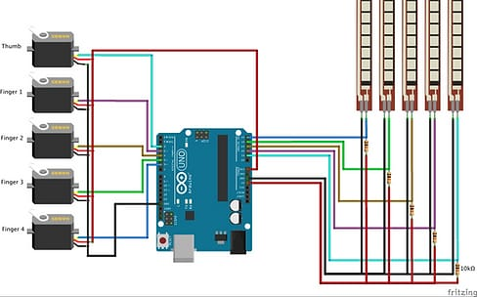

**Literature Review**

**Existing Solutions**

1. Industrial Robotic Arms: Highly expensive and complex to operate.
2. Remote-Controlled Handling Systems: Limited flexibility and high maintenance costs.
3. Wearable Robotic Gloves: Costly and not widely adopted in chemical industries.

**Proposed Approach**

* Use flex sensors to detect finger bending.
* Process signals using an Arduino Nano or ESP32.
* Control 5 servo motors to move robotic fingers.
* Develop a durable and chemical-resistant robotic hand.

**Bill of Materials**

|  |  |  |  |
| --- | --- | --- | --- |
| **S.No** | **Component** | **Specification** | **Cost (INR)** |
| **1** | Microcontroller | Arduino Nano / ESP32 | ₹400-800 |
| **2** | Flex Sensor | 2.2 inch Flex sensor (x5) | ₹1,500 |
| **3** | Servo Motors | TowerPro’s SG90 (x5) | ₹800 |
| **4** | Power Supply | 7.4V Li-ion Battery | ₹800 |
| **5** | 3D Printed Hand | PLA/ABS Plastic | ₹800-4,000 |
| **6** | Model Muscle | Nylon Monofilament Line | ₹200- 4,00 |
|  | Total Cost |  | ₹6,000- 8,000 |